Tenniel Takenaka-Fuller

CPE301 – SPRING 2018

Midterm

**DO NOT REMOVE THIS PAGE DURING SUBMISSION:**

The student understands that all required components should be submitted in complete for grading of this assignment.

|  |  |  |  |
| --- | --- | --- | --- |
| **NO** | **SUBMISSION ITEM** | **COMPLETED (Y/N)** | **MARKS**  **(/MAX)** |
| 1 | COMPONENTS LIST AND CONNECTION BLOCK DIAGRAM w/ PINS |  |  |
| 2. | INITIAL CODE OF TASK 1/A |  |  |
| 3. | INCREMENTAL / DIFFERENTIAL CODE OF TASK 2/B |  |  |
| 3. | INCREMENTAL / DIFFERENTIAL CODE OF TASK 3/C |  |  |
| 3. | INCREMENTAL / DIFFERENTIAL CODE OF TASK 4/D |  |  |
| 3. | INCREMENTAL / DIFFERENTIAL CODE OF TASK 5/E |  |  |
| 4. | SCHEMATICS |  |  |
| 5. | SCREENSHOTS OF EACH TASK OUTPUT |  |  |
| 5. | SCREENSHOT OF EACH DEMO |  |  |
| 6. | VIDEO LINKS OF EACH DEMO |  |  |
| 7. | GOOGLECODE LINK OF THE DA |  |  |
|  |  |  |  |
|  |  |  |  |

1. **COMPONENTS LIST AND CONNECTION BLOCK DIAGRAM w/ PINS**

ATMEGA 328P, stripped wires, an FTDI chip, Evil Mad Scientist target board, the LM35 temperature reader, the ESP8266-01 chip, 5 capacitors, and 5 resistors.

1. A screenshot of a cell phone

   Description generated with high confidence**COMPLETELY DEVELOPED CODE OF TASK 1 AND 2 (from DA3)**

A screenshot of a social media post

Description generated with very high confidence

A screenshot of a cell phone

Description generated with high confidence**A screenshot of a social media post

Description generated with very high confidence3. COMPLETELY DEVELOPED CODE OF TASK 5**

A screenshot of a cell phone

Description generated with very high confidenceA screenshot of a social media post

Description generated with very high confidence

A screenshot of a cell phone

Description generated with very high confidenceA screenshot of a social media post

Description generated with very high confidenceA screenshot of a cell phone

Description generated with very high confidence

1. A close up of a map

   Description generated with very high confidence**SCHEMATICS** A close up of text on a white surface

   Description generated with high confidence

Schematic of task 5 circuit board to transmit UART signals using AT commands.

Schematic of step 1 to 2 circuit board. Transmits ADC to UART.

1. **SCREENSHOT OF TASK 1-2 OUTPUT (ATMEL STUDIO OUTPUT) same as DA3**

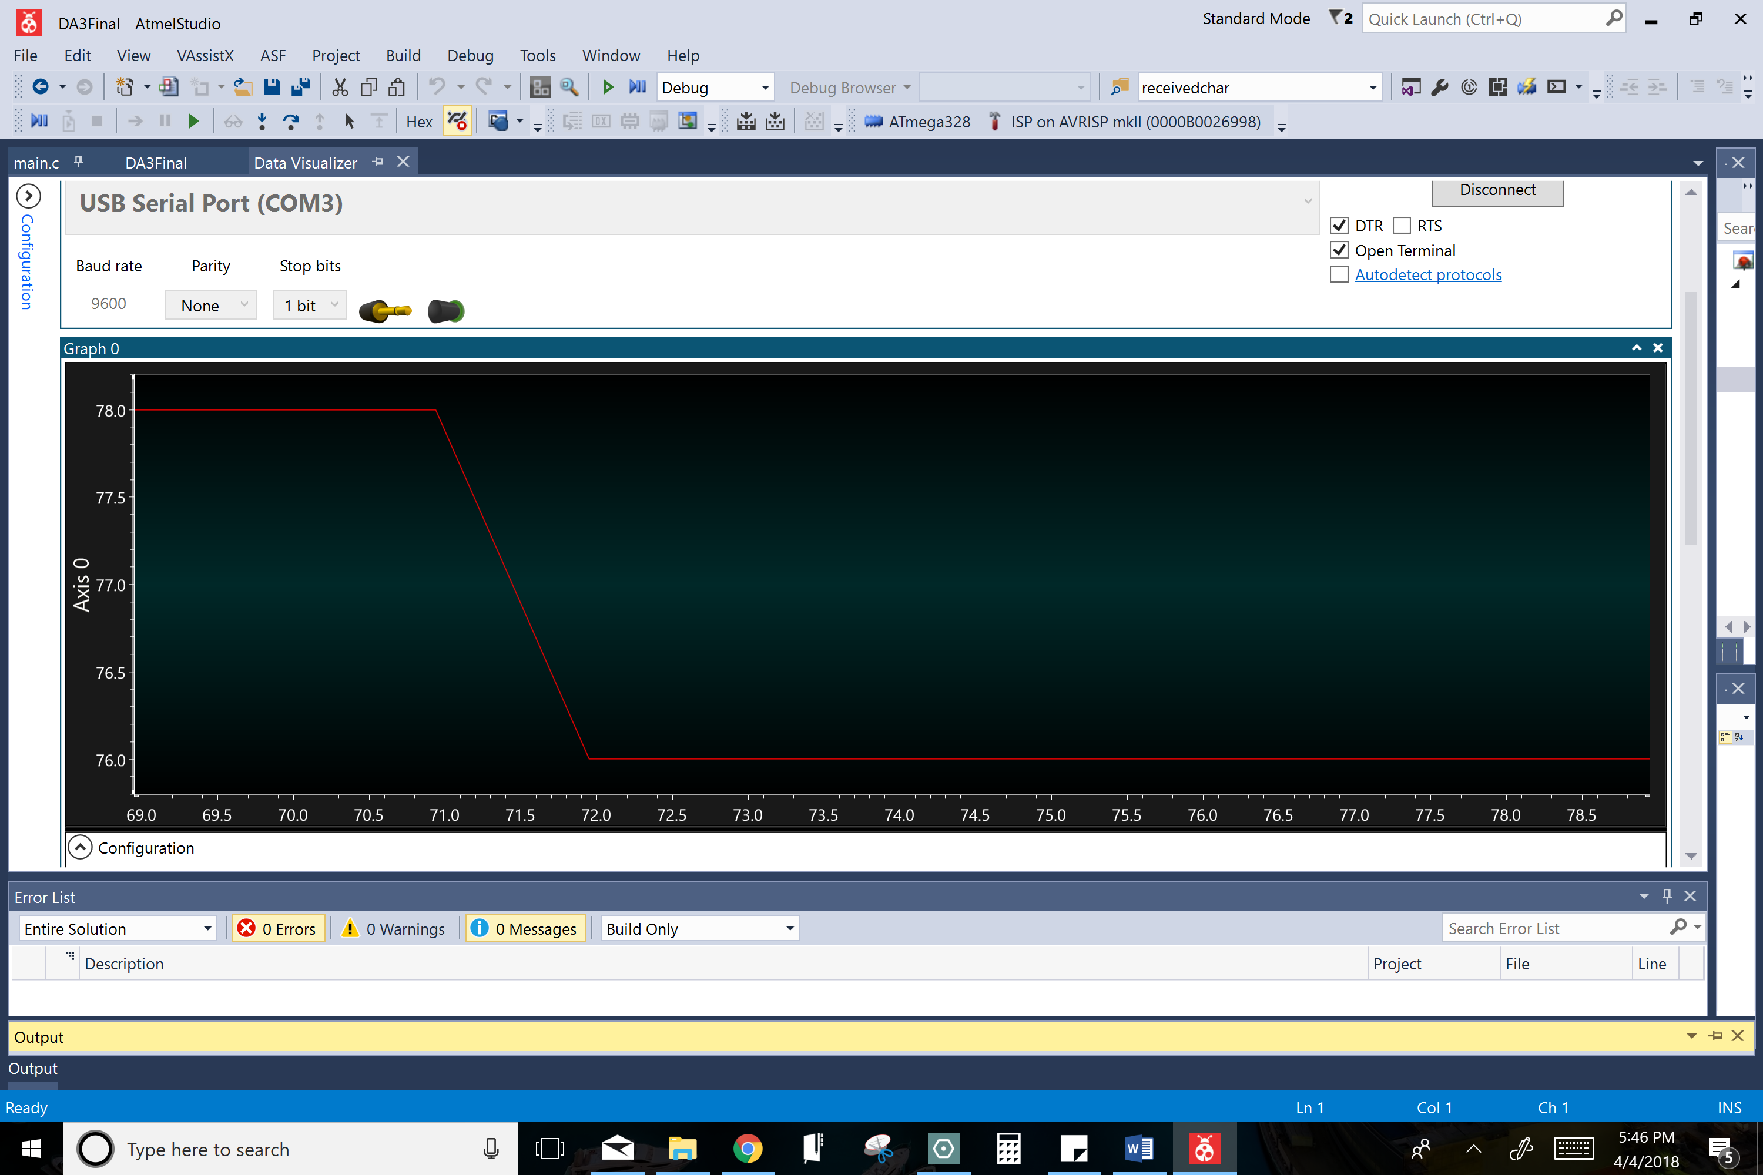

76 degrees is the room temperature the LM35 would read or fall back to unless something very cold or hot would go near it. Pictured here is the LM35 dropping back down to normal room temperature after encountering a hotter temperature.

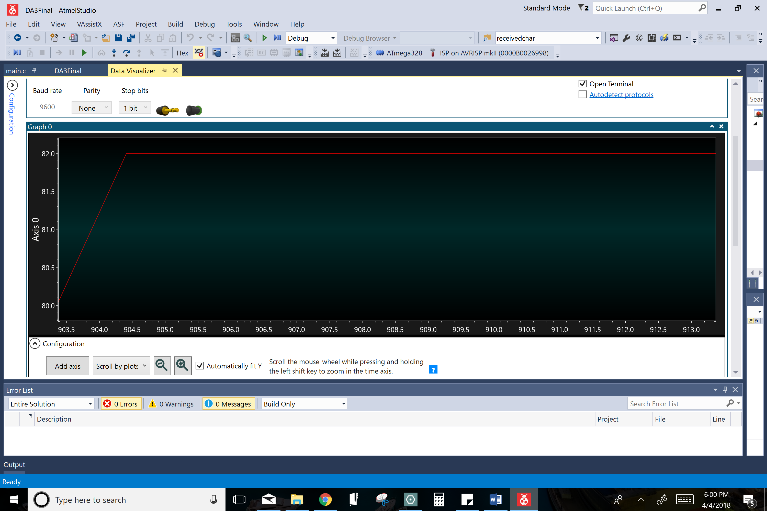

**6. TASK 3 OUTPUT:**

Pictured above is the LM35 is reading a temperature that is hotter than the room temperature. For demonstration purposes, I held the LM35 with my fingers to increase the temperature it read through my finger’s body heat.

The LM35 is steadily reading a temperature that is hotter than the room temperature.

**A screenshot of a computer screen

Description generated with very high confidence**This picture shows the latest version of firmware being installed. Installation is confirmed with a green checkmark in lower left corner.

**7. TASK 4 OUTPUT:**

Channel key for my ThingSpeak account.

A picture containing indoor

Description generated with high confidence

**8. TASK 6 ON HOMEWORK: DISPLAY TEMP SENSOR IN THINGSPEAK GRAPH (TASK 5 OUTPUT)**

**A screenshot of a cell phone

Description generated with very high confidence**

The LM35 is reading room temperature at 76 degrees and graphing this temperature to ThingSpeak.

**A screenshot of a cell phone

Description generated with very high confidence**

**A screenshot of a cell phone

Description generated with very high confidence**

The LM35 is reading a colder temperature and graphing this temperature to ThingSpeak.

The LM35 is reading a steadily increasing hot temperature and graphing this temperature to ThingSpeak.

1. **SCREENSHOT OF EACH DEMO (BOARD SETUP)**

A close up of a device

Description generated with high confidence

**A circuit board

Description generated with very high confidence**

Circuit Board of Task 1-2

Target Board of Task 1-2

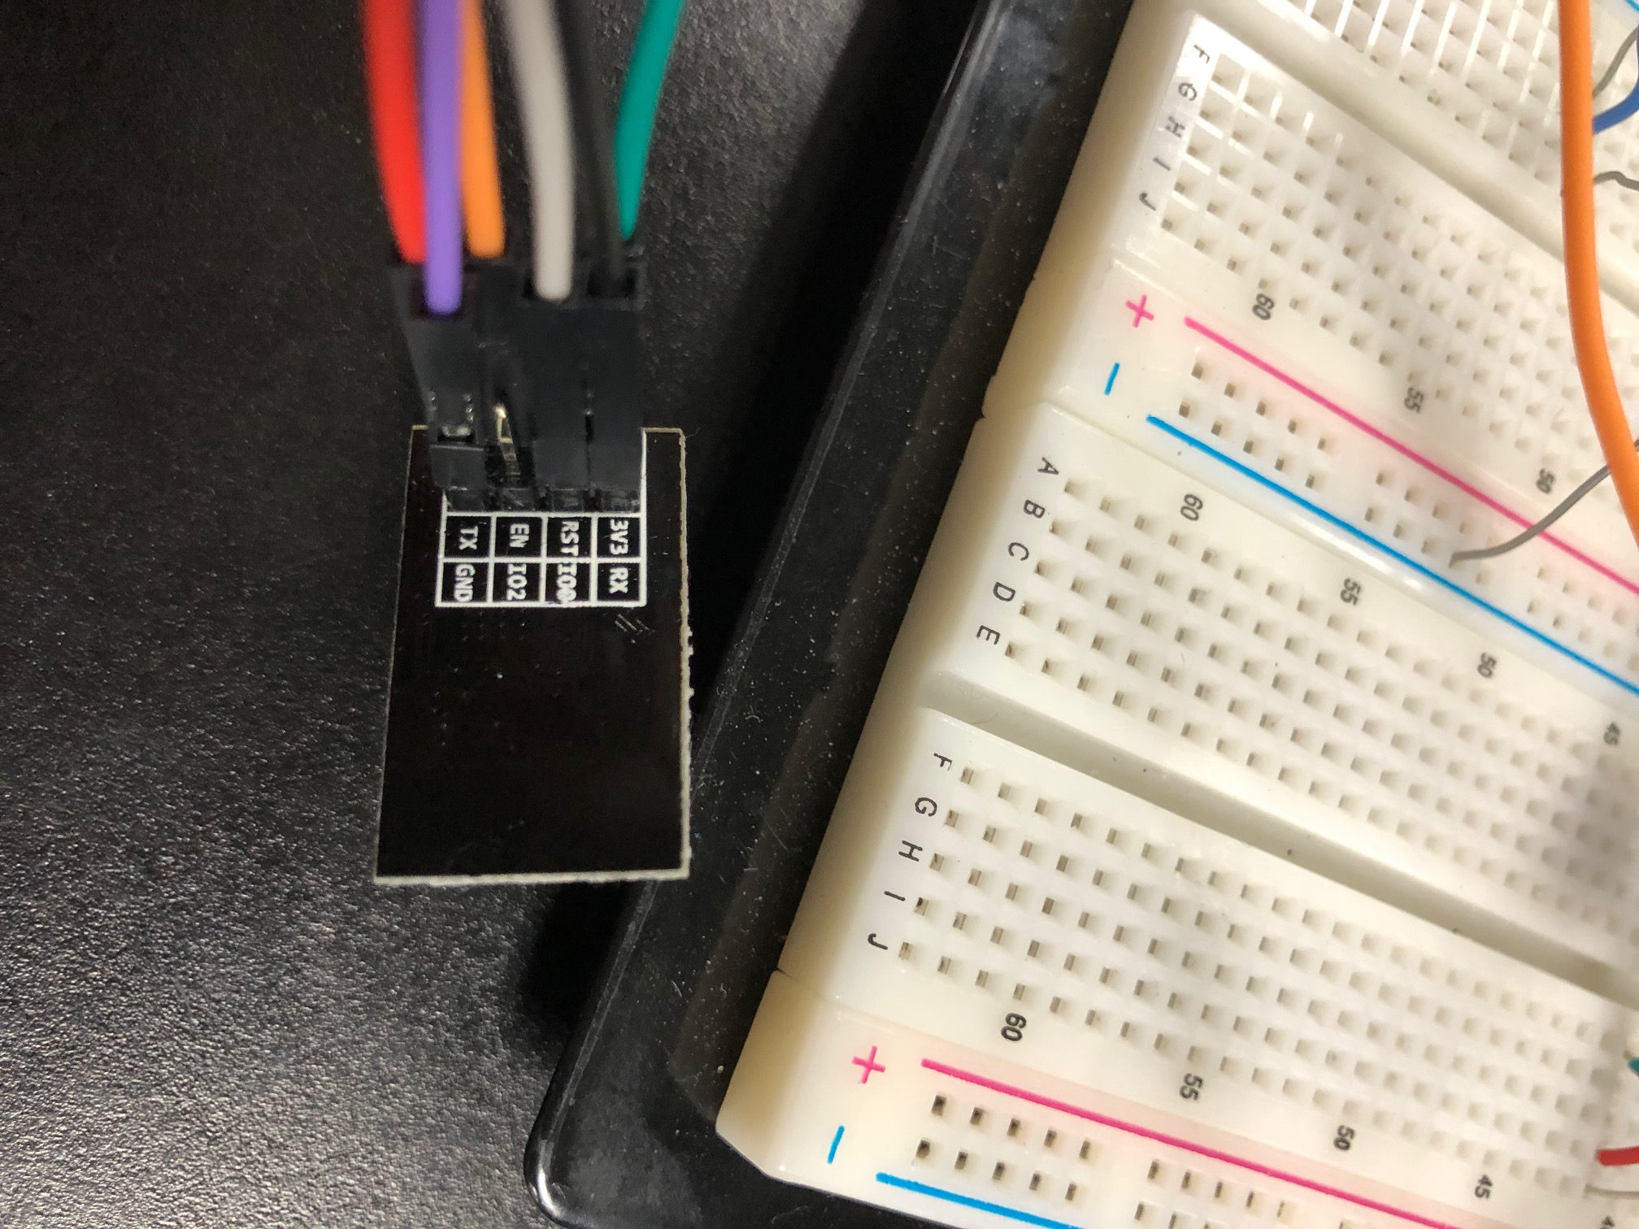**A circuit board

Description generated with very high confidence**

ESP8266-01 set up to download firmware for task 3.

Circuit board of task 3. This set up was specifically needed to install the firmware for the wifi chip.

**A circuit board

Description generated with very high confidence**

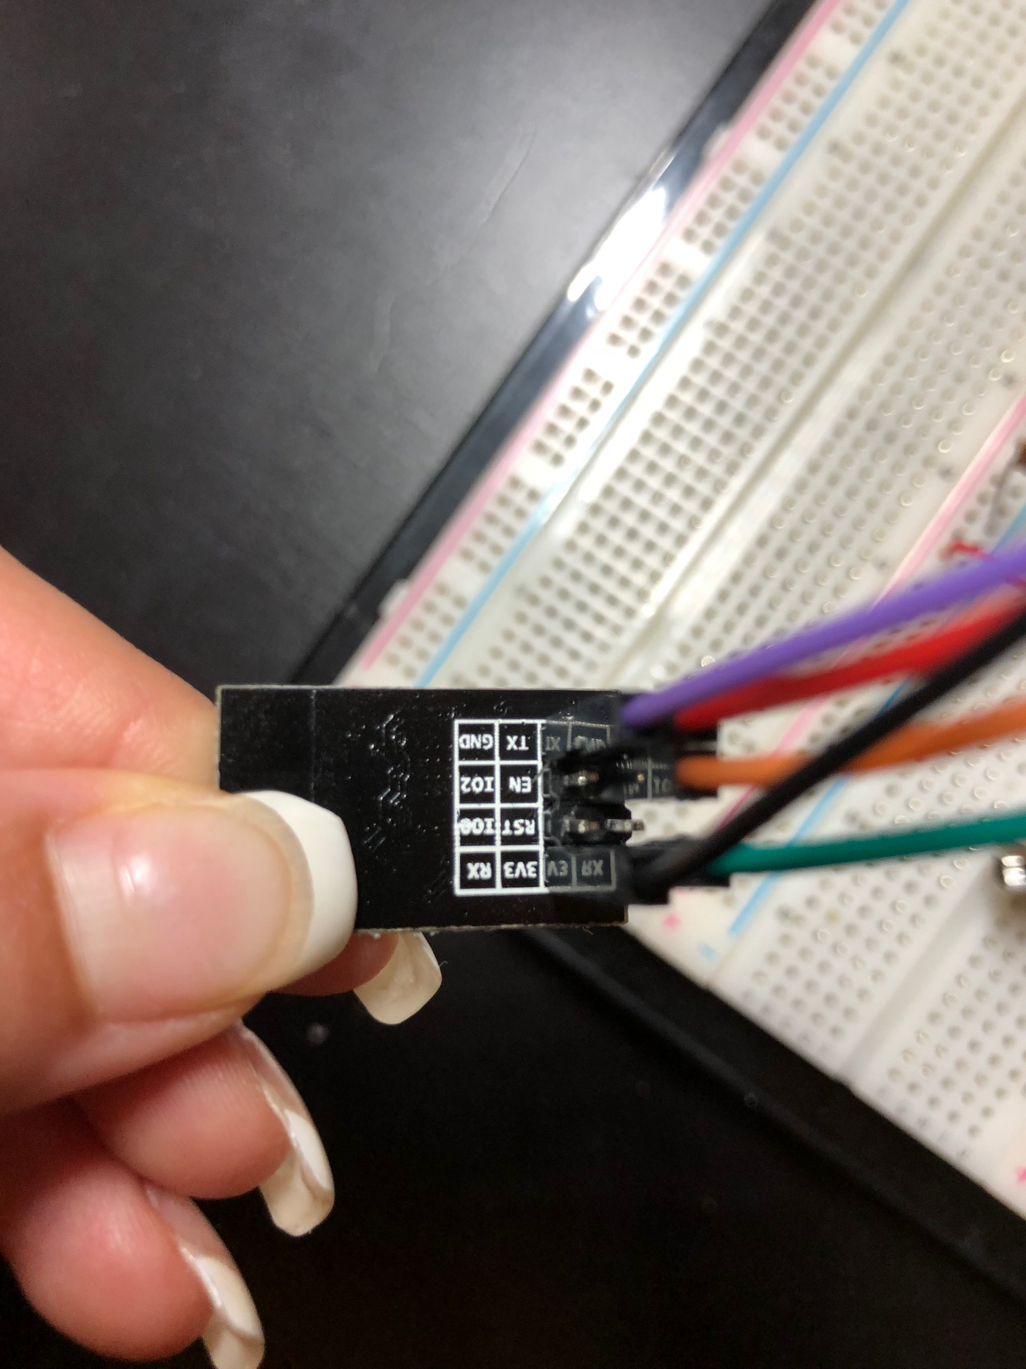

ESP8266-01 of task 5. The wifi chip is used to transmit the temperature value to the ThingSpeak graph.

Circuit board of task 5. This circuit is designed to transmit the temperature value to ESP8255-01 through UART using AT commands.

1. **FLOW CHART OF PROGRAM**

A screenshot of a cell phone

Description generated with very high confidence**A close up of a sign

Description generated with very high confidence**

Flow chart of task 5

Flow chart of task 1-2.

1. **GITHUB & YOUTUBE LINK OF THIS DA**

<https://github.com/TennielTakenaka/Midterm1> | https://youtu.be/u6F8ov3YLmU

**Student Academic Misconduct Policy**

<http://studentconduct.unlv.edu/misconduct/policy.html>

“This assignment submission is my own, original work”.

Tenniel Takenaka-Fuller